SOAPdenovo uitleg/userguide  
  
SOAP is an assembler tool which uses debruijn graphs and runs on most 64 bit Linux distributions and needs a minimum of 5gb of internal memory, it can be downloaded from; <http://sourceforge.net/projects/soapdenovo2/files/SOAPdenovo2/>  
SOAP can be found in two different flavours a bin and a src version. The bin version only has to be extracted and is usable right after, the src version instead has to be compiled first before it can be used.  
  
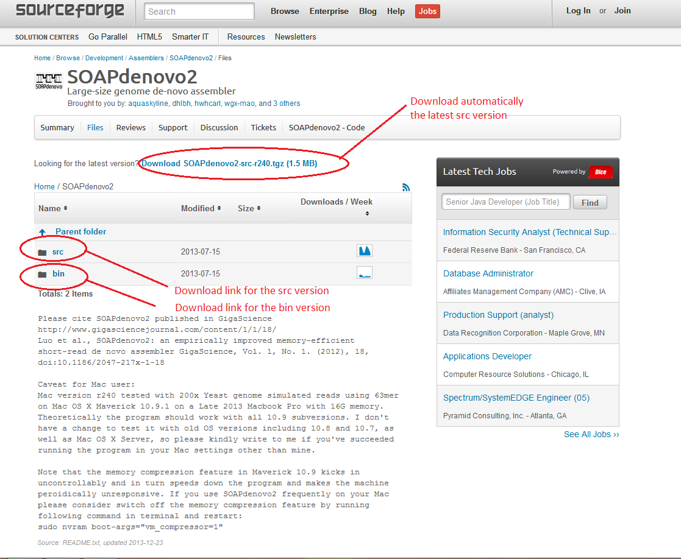

Figuur

After one of the versions has been downloaded it can be extracted in the terminal with the command( in the correct folder containing the appropriate files like, cd /Downloads/SOAP*) "tar -zxf ${destination folder} SOAPdenovo2-src-r240.tgz" for both the bin and the src versions. The src version needs to be compiled before it can be used, to compile the src version use the command "make" in the extracted folder. After that use "make install” to install the executable.

When SOAP is compiled or extracted it can be started with ./SOAPdenovo-63mer(or 127mer) which gives a few options. The major difference between SOAPdenovo-63mer and 127mer is that 127mer has double memory consumption and also accepts kmer sizes greater then 63. For usage with kmers below 63 its adviceble to use always 63mer because even with a kmer setting below 63, 127mer uses twice the amount of memory.

Scripts have been made

To run SOAP with data a textfile is needed, this texfile is used as a configfile, the configfile from SOAP gives the user a lot of options to adjust the assembly, like read length ETC AANVULLEN. But the most important thing in the config file are the paths to the datafiles(fasta, fastq, sam).

A full list with all options can be found below;

max_rd_len=100

[LIB]

avg_ins=200

reverse_seq=0

asm_flags=3

rd_len_cutoff=100

rank=1

insert size)

pair_num_cutoff=3

map_len=32

An explanation for all different options is given below;

maximal read length of the sequences in the dataset

max_rd_len=100

[LIB]

*This value indicates the average insert size of this library or the peak*

*value position in the insert size distribution figure.*

avg_ins=200

*This option takes value 0 or 1. It tells the assembler if the read sequences*

*need to be complementarily reversed. Illumima GA produces two types of*

*paired-end libraries: a) forward-reverse, generated from fragmented DNA ends*

*with typical insert size less than 500 bp; b) reverse-forward, generated from circularizing libraries with typical insert size greater than 2 Kb.*

*The parameter "reverse_seq" should be set to indicate this: 0, forward-reverse;*

*1, reverse-forward.*

reverse_seq=0

*This indicator decides in which part(s) the reads are used. It takes value:*

*1 = only contig assembly*

*2 = only scaffold assembly*

*3 = both contig and scaffold assembly*

*4 = only gap closure*

asm_flags=3

*The assembler will cut the reads from the current library to this length.*

rd_len_cutoff=100

*It takes integer values and decides in which order the reads are used for*

*scaffold assembly. Libraries with the same "rank" are used at the same time*

*during scaffold assembly.*

rank=1

*This parameter is the cutoff value of pair number for a reliable connection*

*between two contigs or pre-scaffolds. The minimum number for paired-end reads and mate-pair reads is 3 and 5 respectively.*

pair_num_cutoff=3

*This takes effect in the "map" step and is the minimun alignment length*

*between a read and a contig required for a reliable read location. The minimum*

*length for paired-end reads and mate-pair reads is 32 and 35 respectively.*

*The assembler accepts read file in three kinds of formats: FASTA, FASTQ and BAM.*

*Mate-pair relationship could be indicated in two ways: two sequence files with*

*reads in the same order belonging to a pair, or two adjacent reads in a single*

*file (FASTA only) belonging to a pair. If a read in bam file fails platform/vendor*

*quality checks(the flag field 0x0200 is set), itself and it's paired read would*

*be ignored. In the configuration file single end files are indicated by*

*"f=/path/filename" or "q=/pah/filename" for fasta or fastq formats separately.*

*Paired reads in two fasta sequence files are indicated by "f1=" and "f2=".*

*While paired reads in two fastq sequences files are indicated by "q1=" and "q2=".*

*Paired reads in a single fasta sequence file is indicated by "p=" item. Reads in*

*bam sequence files is indicated by "b=". All the above items in each library*

*section are optional. The assembler assigns default values for most of them. If*

*you are not sure how to set a parameter, you can remove it from your*

*configuration file.*

map_len=32

An full template of the configfile can be found in the bijlage.

Like stated before one of the most important things in the configfile are the paths to the dataset files, these paths are all different for all sorts of sequence files like fasta and fastq and paired and single reads. Example for a pair of paired end files the path should be; (example states fa en fq files but the files don’t need to be extracted from their gz files)

f1=/path/folderwithsequences/fasta1_read_1.fa

f2=/path/folderwithsequences/fasta1_read_2.fa

When the data consist out of fastq files the paths should be;

q1=/path/folderwithsequences/fastq1_read_1.fq

q2=/path/folderwithsequences/fastq1_read_2.fq

For single end reads the paths are almost equal for a fastq file;  
q=/path/folderwithsequences/fastq1_read_single.fq

For a fasta file;

f=/path/folderwithsequences/fasta1_read_single.fa

When the paths are sorted it is important to remove the unused paths in the config file because SOAP won’t run with them.

When the options are adjusted on the config file SOAP can be run with the command; ./SOAPdenovo-63mer all -s configfilename.config -K 63 -R -o PREFIX>ass.log 2>ass.err for 63mer and ./SOAPdenovo-127mer all -s configfilename.config -K 63 -R -o PREFIX>ass.log 2>ass.err for 127mer, these commandline options require a few required parameters but also has a few optional parameters. The parameters which are required are:

-s <string> configFile: the config file of solexa reads  
-o <string> outputGraph: prefix of output graph file name  
 -K <int> kmer(min 13, max 63/127): kmer size, [23]  
-o <string> outputGraph: prefix of output graph file name  
-R (optional) resolve repeats by reads, [NO] not required but higly recommanded

Optional parameters are:

-p <int> n_cpu: number of cpu for use, [8]  
 -a <int> initMemoryAssumption: memory assumption initialized to avoid further reallocation, unit G, [0]  
-d <int> KmerFreqCutoff: kmers with frequency no larger than KmerFreqCutoff will be deleted, [0]  
-D <int> EdgeCovCutoff: edges with coverage no larger than EdgeCovCutoff will be deleted, [1]  
-M <int> mergeLevel(min 0, max 3): the strength of merging similar sequences during contiging, [1]  
-m <int> max k when using multi kmer  
-e <int> weight to filter arc when linearize two edges(default 0)  
-r (optional) keep available read(*.read)  
 -E (optional) merge clean bubble before iterate  
 -f (optional) output gap related reads in map step for using SRkgf to fill gap, [NO]  
 -k <int> kmer_R2C(min 13, max 63): kmer size used for mapping read to contig, [K]  
 -F (optional) fill gaps in scaffold, [NO]  
-u (optional) un-mask contigs with high/low coverage before scaffolding, [mask]  
 -w (optional) keep contigs weakly connected to other contigs in scaffold, [NO]  
 -G <int> gapLenDiff: allowed length difference between estimated and filled gap, [50]  
 -L <int> minContigLen: shortest contig for scaffolding, [K+2]  
 -c <float> minContigCvg: minimum contig coverage (c*avgCvg), contigs shorter than 100bp with coverage smaller   
 than c*avgCvg will be masked before scaffolding unless -u is set, [0.1]  
 -C <float> maxContigCvg: maximum contig coverage (C*avgCvg), contigs with coverage larger than C*avgCvg or contigs shorter than 100bp with coverage larger than 0.8*C*avgCvg will be masked before scaffolding unless -u is set, [2]  
-b <float> insertSizeUpperBound: (b*avg_ins) will be used as upper bound of insert size for large insert size  
 ( > 1000) when handling pair-end connections between contigs if b is set to larger than 1, [1.5]  
-B <float> bubbleCoverage: remove contig with lower cvoerage in bubble structure if both contigs' coverage are smaller than bubbleCoverage*avgCvg, [0.6]  
-N <int> genomeSize: genome size for statistics, [0]  
-V (optional) output visualization information of assembly, this option creates an .asm file which can be used in Amos Hawkeye viewer.

After the command is written to the needs of the user it can be run with the press of enter, now if everything is correct SOAP will start with the assembly. The terminaloutput with runtime, and results like n50 etc.. wil be written in the logfile which can be found in the SOAP folder this is very usefull to check the quality of the assembly The runtime depends greatly on the amount of sequences in the file(s), the runtime can last hours or even days. When SOAP is finished it writes a few output files, the files which are the most usefull are listed below;  
  
.contig contains the contigs from the assembly  
.scaf containts the scaffolds from the assembly  
.err is a text file with detailed informatie about the assembly like runtime, n50, contig length, very usefull to get a fast detailed look.

When –V is used as parameter in the commandline SOAP will also create an asm file which can be opened with AMOS Hawkeye (http://sourceforge.net/apps/mediawiki/amos/index.php?title=Hawkeye).  
The installation from AMOS Hawkeye viewer can be a bit difficult because to use the Hawkeye viewer a few dependencies are needed, these dependencies can be difficult to install(depending on the Linux distro)

https://wiki.nbic.nl/index.php/Raw_results_of_NGS_de_novo_assembly

bin versie

config file:

#iets laten draaien

./SOAPdenovo-63mer all -s configfilename.config -K 63 -R -o graph_prefix1 > ass.log 2 > ass.err

-o is een prefix voor de bestanden

of 127mer, voor testen zie config.test in de soapdenovo map

q1=~/Downloads/C0A7AACXX_101851-02_TGACCA_L001_R2.fastq.gz

http://assemblathon.org/

Bijlage configfile (save as yourname.config)

#maximal read length

max_rd_len=100

[LIB]

#average insert size

avg_ins=200

#if sequence needs to be reversed

reverse_seq=0

#in which part(s) the reads are used

asm_flags=3

#use only first 100 bps of each read

rd_len_cutoff=100

#in which order the reads are used while scaffolding

rank=1

# cutoff of pair number for a reliable connection (at least 3 for short insert size)

pair_num_cutoff=3

#minimum aligned length to contigs for a reliable read location (at least 32 for short insert size)

map_len=32

#weghalen wat niet wordt gebruikt

#maar vier files totaal of?

#a pair of fastq file, read 1 file should always be followed by read 2 file

q1=/path/**LIBNAMEA**/fastq1_read_1.fq

q2=/path/**LIBNAMEA**/fastq1_read_2.fq

#another pair of fastq file, read 1 file should always be followed by read 2 file

q1=/path/**LIBNAMEA**/fastq2_read_1.fq

q2=/path/**LIBNAMEA**/fastq2_read_2.fq

#a pair of fasta file, read 1 file should always be followed by read 2 file

f1=/path/**LIBNAMEA**/fasta1_read_1.fa

f2=/path/**LIBNAMEA**/fasta1_read_2.fa

#another pair of fasta file, read 1 file should always be followed by read 2 file

f1=/path/**LIBNAMEA**/fasta2_read_1.fa

f2=/path/**LIBNAMEA**/fasta2_read_2.fa

#fastq file for single reads

q=/path/**LIBNAMEA**/fastq1_read_single.fq

#another fastq file for single reads

q=/path/**LIBNAMEA**/fastq2_read_single.fq

#fasta file for single reads

f=/path/**LIBNAMEA**/fasta1_read_single.fa

#another fasta file for single reads

f=/path/**LIBNAMEA**/fasta2_read_single.fa

#a single fasta file for paired reads

p=/path/**LIBNAMEA**/pairs1_in_one_file.fa

#another single fasta file for paired reads

p=/path/**LIBNAMEA**/pairs2_in_one_file.fa

#bam file for single or paired reads, reads 1 in paired reads file should always be followed by reads 2

# NOTE: If a read in bam file fails platform/vendor quality checks(the flag field 0x0200 is set), itself and it's paired

read would be ignored.

b=/path/**LIBNAMEA**/reads1_in_file.bam

#another bam file for single or paired reads

b=/path/**LIBNAMEA**/reads2_in_file.bam